“AI-Based Earthquake Detection System using Gradio”

Abstract: The Earthquake AI Detection Dashboard is a sophisticated tool used for detecting abnormalities within earthquakes through machine learning approaches. The tool takes sequential inputs from earthquakes in terms of latitude, longitude, depth, magnitude, and RMS. Then, the inputs are analyzed using an LSTM Autoencoder model, which learns about regular earthquake patterns and detects any abnormalities depending on the reconstruction error. An interactive tool created using the Gradio platform enables users to input information, analyze predictions, see graphs, and visualize the location of earthquakes. The use of the dashboard provides benefits for monitoring and analyzing earthquakes in real-time.
Keywords: Earthquake Detection, LSTM Autoencoder, Gradio Dashboard, Machine Learning, Seismic Analysis, Anomaly Detection, Deep Learning, Time Series Data, Artificial Intelligence, Disaster Monitoring
Background and Problem Definition
Seismic waves are produced as a result of earthquakes and travel throughout the Earth. The waves are monitored through seismic stations and recorded as time series data. The data contains information about the motion of the earth and has great significance in identifying seismic events, volcano occurrences, aftershocks and many other abnormalities related to tectonic movement of the earth. Through analysis of different characteristics like amplitude, frequencies, and patterns of the wave, researchers can find out whether there has been a seismic event and its intensity and location as well. Hence, recording and monitoring of the data has become crucial from disaster prevention perspectives.
Specific Problem Definition
The problem that is being addressed by this research work is the automatic identification of anomalies in seismic time series data by employing deep learning algorithms. The goal is to identify anomalous behavior patterns in seismic data, which can be used for identifying earthquake activity with a minimal number of false alarms [3]. The system does not depend solely on threshold values and predefined feature vectors. It learns the patterns of normal seismic behavior based on existing data and identifies abnormal signals. This is quite a difficult problem due to the fact that the events of earthquake activity are rare compared with the patterns of normal seismic activity. The majority of the data is characterized by the absence of an earthquake, thus creating an imbalanced set of input data.
Importance of Deep Learning
This issue is relevant in the battle of deep learning since time-series models like LSTM networks and autoencoders are capable of acquiring, including, for instance, nonlinear patterns andcomplex temporal dependencies that are complex. The creation of a powerful and efficient system of anomaly detection with deep learning can greatly enhance the process of real-time monitoring of earthquakes, the system of early warning, and decrease the use of manual interpretation.
Proposed Deep Learning Solution
High-Level Description
The suggested earthquake anomalies detector consists of a deep learning framework, which would allow for the identification of the patterns present in the seismograph time-series. The main purpose of the algorithm will be to detect any unusual seismic activity based on the normal motion patterns of earthquake related data. Seismic data has a sequential nature; therefore, it needs a certain approach that allows for capturing the time-dependent relations and tendencies within the series. In prediction, the model produces an anomaly score for each time window, which means whether the signal is particularly different or not within the learnt normal patterns.
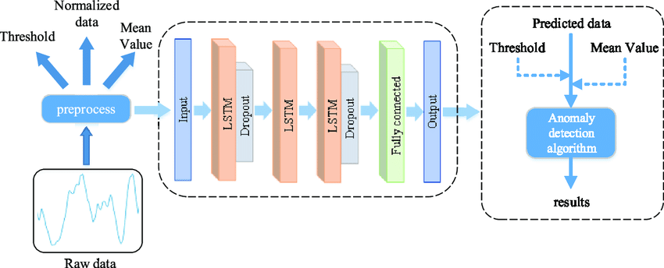
Fig. 1: Architecture of the Proposed LSTM-Based Time-Series Anomaly Detection Model
Model Tackles the Problem
In order to solve the aforementioned problem, the proposed machine learning model could be trained via a supervised learning technique or an unsupervised learning algorithm based on whether the available seismic data are labelled. If the historical earthquake dataset contains labelled examples, then a supervised learning algorithm would be used to train the model by learning how to distinguish between typical seismic behavior and earthquakes. This way, the model will have the ability to classify any incoming signal as either an earthquake or normal seismicity.
Innovative/Unique Aspects
This solution is innovative since it has a dynamic scoring of anomalies in real-time and a dynamic thresholding approach, which modulates the sensitivity of detection [4]. Also, the raw seismic signal plus extracted spectral features decreases the false positives and increases the accuracy of the detection in noisy environments.
Data Selection
For the purpose of training and testing the model, seismic time series data have been obtained from credible open sources like the USGS Earthquake Catalogue and IRIS Seismic Data Archives. The credibility of the above-mentioned database sources is well acknowledged by their reputation of storing genuine and timely recorded information regarding earthquakes that occur at various seismic stations around the world. These consist of useful records related to earthquake activity, geological events, etc., making them very effective for use in seismic analysis [5]. The chosen datasets contain valuable features such as event time, latitudinal and longitudinal coordinates, depth, magnitude, RMS value, and other measurements made using sensors.
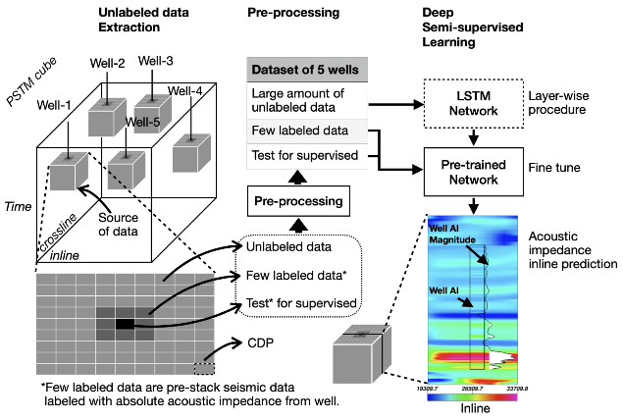
Fig. 2: Workflow of Seismic Data Collection and Preprocessing Pipeline
Suitability of Data
The chosen dataset is well suited for this deep learning assignment, as it contains real world time series data with high frequency. The data includes signals corresponding to tectonic movements and earthquakes occurring in reality. As seismic stations continuously monitor the vibration activity in the ground, this makes the data useful for studying anomalies through analysis of trends over time. For making predictions about anomalies, changes in sequential patterns in time series are essential, making it an ideal format for developing LSTM models.
Data Volume and Challenges
Seismic data is large-scale, and the generation of seismic data is continuous: it has a volume and nature of gigabytes or terabytes, depending on the duration and sampling rate. It may encounter potential challenges of noise contamination, missing values, class imbalance (earthquake is a rare occurrence), and heavy computation needs in case of processing long time-series sequences [6].To overcome these challenges, proper preprocessing, normalization, and window segmentation have been used.
Preparing the Data
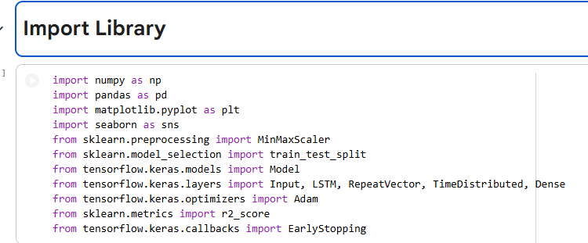
Fig. 3: Import Library for Earthquake Detection System
The above figure illustrates the Python libraries that are required for the implementation of the earthquake anomaly detection system. Such libraries include NumPy and Pandas, which deal with data manipulation and calculations. Visualization can be done using Matplotlib and Seaborn. Scikit-learn library takes care of preprocessing and performance assessment. TensorFlow and Keras libraries have been used in creating the LSTM Autoencoder deep learning algorithm [7]. The Early Stopping technique has been used to avoid overfitting when training the model. The above set of libraries provides a complete platform for machine learning, visualization, and data analysis.
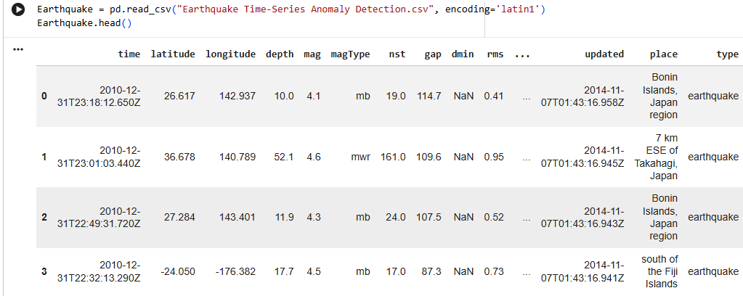
Fig. 4: Earthquake Dataset Loading and Preview
The above figure presents the earthquake dataset after importing the CSV file using Pandas. This dataset consists of features such as the date, latitude, longitude, depth, magnitude, RMS, and location among others. The data represents earthquake records from various parts of the world. Data previewing is an important initial step since it will enable the user to verify the quality of the data and column names [8].
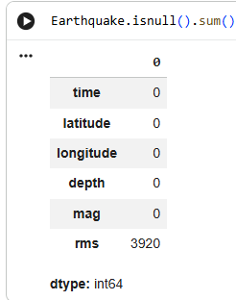
Fig. 5: Missing Values Detection in Dataset
Figure 1 shows the output obtained by applying the function isnull().sum() to determine the presence of null values. It can be seen that all the columns, except the RMS column, have no missing values. In the RMS column, there are 3920 missing values. The presence of null values is critical since it affects the performance of the model. Imputation, forward fill, and deletion of missing values are some of the techniques used to address missing data.
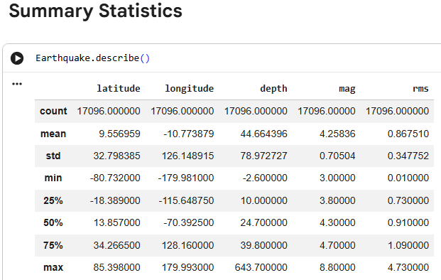
Fig. 6: Summary Statistics of Earthquake Data
This is a statistical representation of the data generated by the function describe(). This includes the count, mean, standard deviation, minimum, quartiles, and maximum values of latitude, longitude, depth, magnitude, and RMS. For instance, the magnitude of earthquakes is between 3.0 and 8.8. Statistical representation is useful as it enables one to understand the spread, central tendencies, etc., in the data [9].
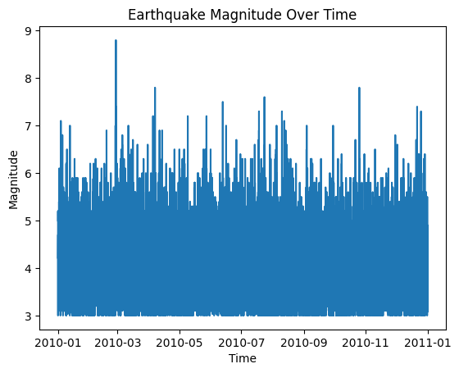
Fig.7: Earthquake Magnitude Over Time
The plot below is used to show the evolution of the magnitudes of the earthquakes over time. Time is displayed on the x-axis, while magnitude is represented on the y-axis. The majority of earthquakes have magnitudes between 3 and 6, and sometimes there are sudden rises to magnitudes greater than 7. This implies that larger earthquakes have occurred. Time-series visualization can help to determine the number of events occurring and their variation and extremes. This will be useful in learning about temporal patterns to enable the LSTM Autoencoder model to learn.
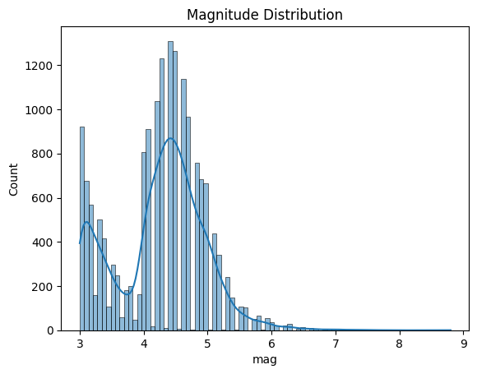
Fig. 8: Magnitude Distribution Histogram
The chart below shows the distribution of magnitudes of earthquakes in terms of density. Most events occur at magnitudes between 4 and 5. This means that moderate earthquakes occur frequently. On the other hand, fewer events happen at magnitudes greater than 6. Right-skewed distribution indicates that extreme earthquakes rarely happen [10]. Distribution is essential because any abnormal values such as high magnitude earthquakes can be captured.
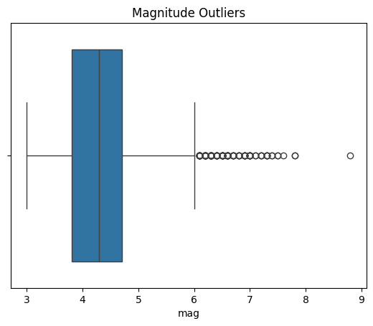
Fig. 9: Magnitude Outliers Boxplot
The above graph shows a box plot that is useful in detecting any outlier values from earthquake magnitudes. The box plot illustrates the interquartile ranges while the line indicates the median value. There are some points above the upper whisker, which indicate the presence of some outliers of high magnitude values, including one at 8.8. These are seismic outliers. Identifying outliers is important in determining whether there have been any abnormal events. Such data is valuable in the model’s evaluation.
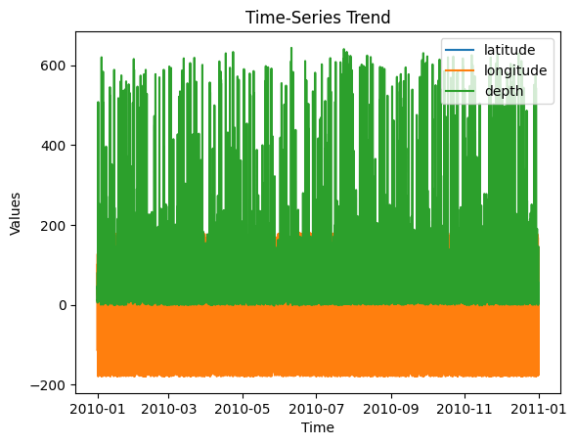
Fig. 10: Time-Series Trend of Latitude, Longitude, and Depth
The above graph is a time series analysis of the latitudes, longitudes, and depth of an earthquake event. The fluctuations in the geographical locations and seismic depth show that there have been varying earthquakes taking place from different locations and depth levels [11]. Such kind of multivariate sequential data is ideal for LSTM models since these can learn patterns within various input variables at the same time.
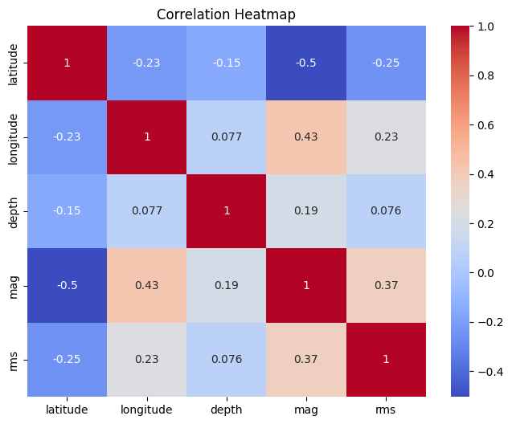
Fig. 11: Data loading, preprocessing, and implementing EDA
The data is imported with the help of pandas and processed by converting the time column to datetime and sorting it according to date. Numerical characteristics like latitude, longitude, depth, magnitude, and RMS are identified as relevant. Filling values that are missing is done through forward fill. Distributions and correlations of the data, time-series plots, histograms, boxplots, and a correlation heatmap are used to perform Exploratory Data Analysis (EDA) to gain knowledge about trends.
Defining the Deep-Learning Model
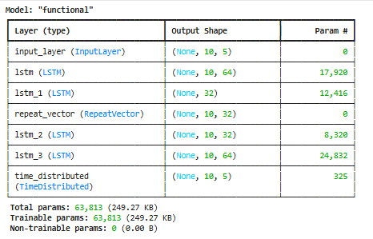
Fig.12: Deep Learning Model
The LSTM Autoencoder model is a time-series reconstruction of encoder and decoder layers and has several LSTM layers, a RepeatVector, and a TimeDistributed layer [12]. The model trains temporal patterns and reconstructs sequences of inputs to detect anomalies successfully based on reconstruction errors.
Training and Fine-Tuning Model
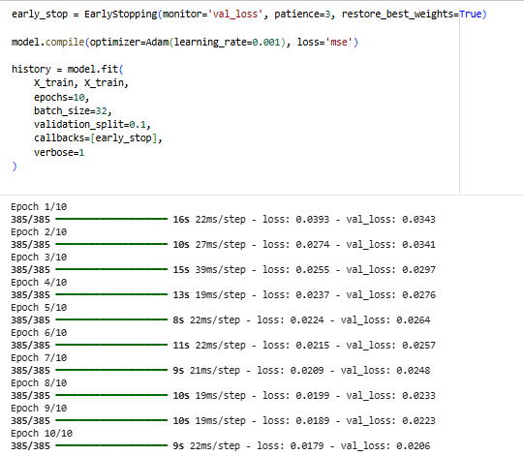
Fig. 13: LSTM Autoencoder Model Training Process
The graph below represents the training output of the LSTM Autoencoder model throughout various epochs. There is an obvious decline in the loss and validation loss values through the initial and last epoch. It signifies that the LSTM model is effectively learning the input. The application of EarlyStopping will help stop training if the validation accuracy stops increasing. It will reduce the risk of overfitting.
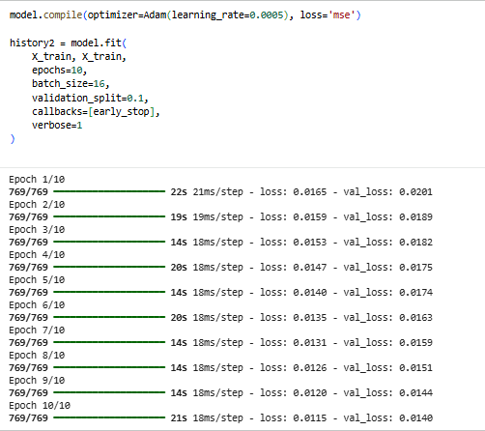
Fig. 14: Hyperparameter using Model Training
Hyperparameter optimisation to optimize model performance is done by changing the learning rate, batch size, and epochs. EarlyStopping helped to avoid overfitting and maintain optimum weights [13]. The effectiveness of tuning in to improve model stability and performance is also proven by comparing two training configurations with better convergence and lower validation loss.
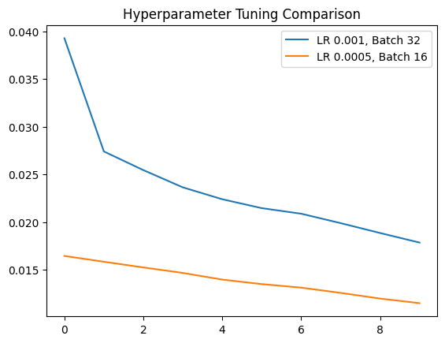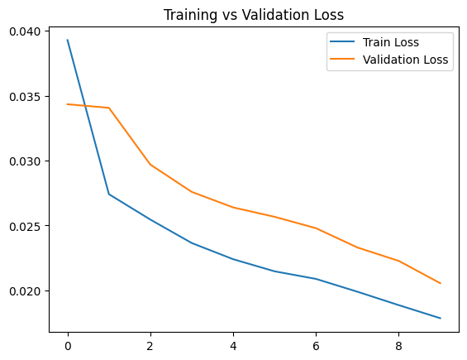
Fig. 15: Hyperparameter Tuning Comparison and Training vs Validation Loss
The line plots show that the hyperparameter tuning affects the performance of the model [18]. The tuned model (reduced learning rate and batch size) has better convergence and loss than the baselines. The training and validation loss curves stabilise and deviate downwards, meaning that learning is stable, and overfitting is mostly minimal to guarantee enhanced model performance and generalisation.
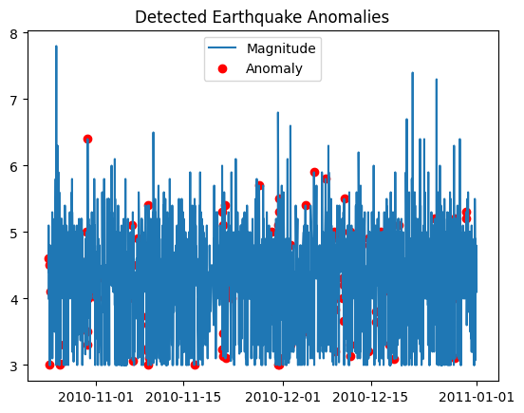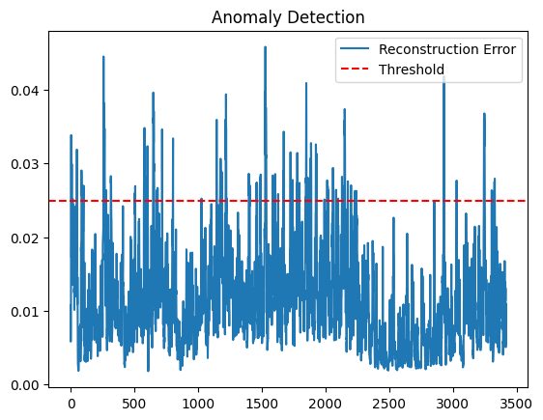
Fig. 16: Detected Earthquake Anomalies and Anomaly Detection
The occurrence of earthquake anomalies as per the reconstruction error implemented using python in google colab. Red points represent anomalies with reference to typical spikes of magnitude. The normal and abnormal patterns are properly divided with the help of the threshold line [14]. The model is able to identify the abnormal seismic activities, and this illustrates that it can detect the abnormality in the time-series earthquake data, with the help of reconstruction error analysis.
Testing Your Model with New Data
The designed earthquake detector has been constructed using Python with modern libraries including TensorFlow, Gradio, Pandas, NumPy, Plotly, and Scikit-learn. Such tools form a fully-fledged ecosystem for deep learning, data handling, visualisation, and deployment. Specifically, the LSTM Autoencoder algorithm has been created using TensorFlow, whereas Pandas and NumPy have been used for data processing and numeric calculations, respectively. In order to test the algorithm on new data, the input format of time series earthquake events with the shape (10,5) has been employed to represent ten observations and five significant parameters, namely latitude, longitude, depth, magnitude, and RMS.
Code Documentation
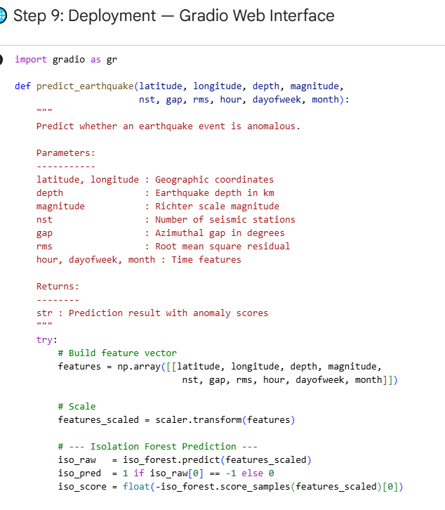
Fig 17: Gradio Dashboard Code Execution
The code starts off by importing necessary Python libraries, as well as setting up the dashboard layout. The use of TensorFlow, Pandas, NumPy, Plotly, and Scikit-learn libraries are required for executing models, data manipulation and processing, visualization, and scaling. Gradio is employed to develop an interactive dashboard interface where users are able to evaluate the functionality of the earthquake detection model.

The deep learning model (model.h5) and scaler files (scaler.pkl) are loaded using a caching function in order to increase the speed of the process each time it runs. An initial dataset with pre-entered data about some default earthquakes is shown in an editable table where the user may change the values, or else he/she would enter his/her own ten earthquake records with features of latitude, longitude, depth, magnitude, and RMS values. When the Detect Anomaly button is pressed, the input data is first scaled and then reshaped to be fed into the LSTM Autoencoder model [15].
Deploying Your Model
The earthquake detection project is executed locally using Visual Studio Code and a Python virtual environment. An isolated environment, known as a virtual environment, is set up to avoid any possible conflicts with other installed modules in running the project smoothly. All the necessary libraries including TensorFlow, Gradio, Pandas, NumPy, Plotly, and Scikit-learn are installed through pip.
Results and Analysis
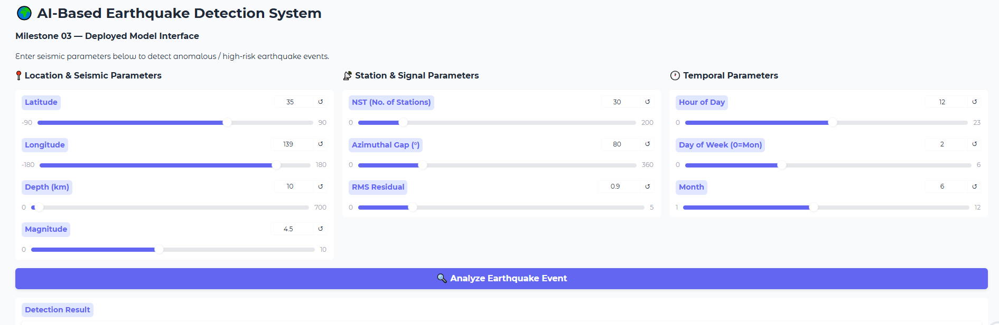
Fig 18: Earthquake AI Detection Dashboard – Input Interface
This interface consists of an editable table that contains the earthquake data records within a user-friendly interface of a dashboard. This table includes essential seismic attributes such as latitude, longitude, depth, magnitude, and RMS value that the model needs for the detection of anomalies [16]. These seismic attributes describe the intensity and behavior of seismic events.
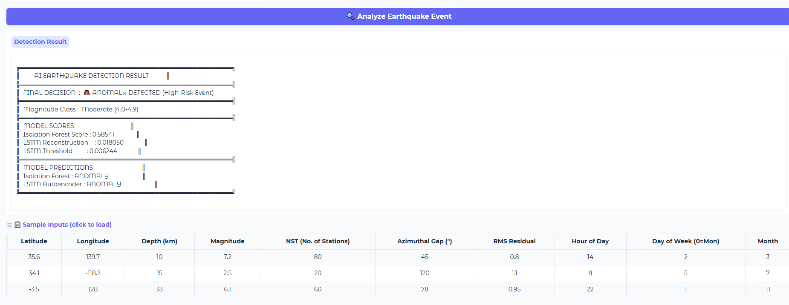
Fig 19: AI Analysis Result with Magnitude Trend
The system shows loss score, threshold value and prediction status as normal activity. Magnitude trend graph is a graphical representation that depicts changes in the earthquake intensities in sequential order, which can be used to rapidly interpret seismic trends [17]. The dashboard shows a bar chart that shows the change in the depth of earthquakes in records. Seismic coordinates are overlaid on a geographic map and this assists the user to visualise the spatial distribution and the activity of earthquakes in the region.
Conclusion
Earthquake AI Detection Dashboard showcases the successful integration of deep learning and visualization techniques for effective earthquake detection in the modern world. The LSTM Autoencoder neural network is able to detect abnormal behavior through the analysis of sequential seismic inputs, including coordinates, depth, magnitude, and RMS values. The reconstruction error method allows the system to differentiate between regular seismic behavior and abnormalities in tectonic plate movement. Gradio dashboard adds practical value to the project by enabling live prediction, visual graph representation, tabular information, and geographical mapping. These tools make it easier to analyze the behavior of earthquakes and gain insight into possible abnormalities. The current project strives to ensure the practical realization of the utilization of the artificial intelligence technology in the control of the disasters. One additional way to optimize the process is through real-time aggregation of the data, creation of alerts automatically, and storing of the data in the cloud.
One more important contribution of the current project is automation of the identification of the anomalies. This means that there will not be any need for manual analysis of big seismic data, which has already been collected. With the occurrence of earthquakes continuously, there is a need for the software to perform analysis of such data in an effective manner. Moreover, the dashboard increases the knowledge regarding the risks posed by earthquakes as well as making quick decisions during emergency cases. In future, improvements can be done to the current model by integrating it with live seismic data sources and using cloud computing.
References
[1] Shabrawy, M., Abdel-Hamid, N.B., El-Kenawy, E.S.M. and Abdelsalam, M.M., Comparative Advances in AI-Driven Earthquake Intelligence: Machine Learning, Deep Learning, and Large Language Models for Prediction and Emergency Management.
[2] Fulgione, M., Palladino, S., Esposito, L., Sarfarazi, S. and Modano, M., 2025. A multi-stage framework combining experimental testing, numerical calibration, and AI surrogates for composite panel characterisation. Buildings, 15(21), p.3900.
[3] Zhu, R., Yang, F., Zhou, X., Tian, J., Zhang, Y., He, M., Li, J., Dong, J. and Li, Y., 2024. Anomaly detection using machine learning in hydrochemical data from hot springs: implications for earthquake prediction. Water Resources Research, 60(6), p.e2023WR034748.
[4] Tokgöz, G. and Avanoğlu Sıcacık, E., 2026. Feature-driven LSTM model for earthquake-based anomaly detection in noisy environments. Neural Computing and Applications, 38(2), p.23.
[5] Seo, J., Kim, Y., Ha, J., Kwak, D., Ko, M. and Yoo, M., 2024. Unsupervised anomaly detection for earthquake detection on Korea high-speed trains using autoencoder-based deep learning models. Scientific Reports, 14(1), p.639.
[6] Abdalzaher, M.S., Fouda, M.M., Elsayed, H.A. and Salim, M.M., 2023. Toward secured IoT-based smart systems using machine learning. IEEE access, 11, pp.20827-20841.
[8] Kuglitsch, M.M., Albayrak, A., Luterbacher, J., Craddock, A., Toreti, A., Ma, J., Vilela, P.P., Xoplaki, E., Kotani, R., Berod, D. and Cox, J., 2023. When it comes to Earth observations in AI for disaster risk reduction, is it feast or famine? A topical review. Environmental Research Letters, 18(9), p.093004.
[9] Shen, Q. and Zhang, J., 2026, January. AI-enhanced disaster risk prediction with explainable SHAP analysis: A multi-class classification approach using XGBoost. In 2026 5th International Symposium on Computer Applications and Information Technology (ISCAIT) (pp. 692-698). IEEE.
[10] Karaman, B., Basturk, I., Taskin, S., Kara, F., Zeydan, E. and Yanikomeroglu, H., 2024. Enhancing resiliency of integrated space-air ground-sea networks with renewable energies: A use case after the 2023 Türkiye earthquake. IEEE Communications Magazine, 62(12), pp.104-111.
[11] Caballero, J., Perez-Mon, O., R-Moreno, M.D. and de Oliveira Filho, J., 2023, November. Integral AI-based planning for management of WSNs in military operations. In 2023 IEEE 35th International Conference on Tools with Artificial Intelligence (ICTAI) (pp. 341-348). IEEE.
[12] Alnoman, A., Khwaja, A.S., Anpalagan, A. and Woungang, I., 2024. Emerging AI and 6G-based user localization technologies for emergencies and disasters. IEEE Access, 12, pp.197877-197906.
[13] Shafapourtehrany, M., Batur, M., Özener, H., Lorestani, N., Kalantar, B. and Shabani, F., 2026. Conventional and advanced geospatial techniques for landslide detection and modeling: a comprehensive overview. Geoenvironmental Disasters, 13(1), p.3.
[14] Gowekar, G.S., 2024. How oil and gas industry are transforming with AI and ML. World Journal of Advanced Research and Reviews, 23(3), pp.1234-1238.
[15] Saengtabtim, K., Leelawat, N., Aumnoysombat, R., Adelifar, M., Saengwongwattana, N., Suktavornprasit, G., Suppasri, A., Imamura, F. and Tang, J., 2025. Harnessing generative AI for enhanced disaster management: a systematic review. Big Earth Data, 9(4), pp.651-675.
[16] Yagan, M.Y., Kayraklik, S., Kesir, S., Sumen, G., Hokelek, I., Basaran, M., Alexandropoulos, G.C., Basar, E., Cavdar, C., Arslan, H. and Gorcin, A., 2024. Fast network recovery from large-scale disasters: A resilient and self-organizing RAN framework. arXiv preprint arXiv:2408.08609.
[17] Karunaharan, V., Gayan, S., Luckshan, C., Singh, R., Inaltekin, H., Shin, W. and Han, Z., 2026. A Comprehensive Survey on 6G and Beyond for Climate Action: Toward Sustainable Connectivity. IEEE Access.
[18] Adu-Manu, K.S., Abdulai, J.D., Engmann, F., Akazue, M., Appati, J.K., Baiden, G.E. and Sarfo-Kantanka, G., 2022. WSN architectures for environmental monitoring applications. Journal of Sensors, 2022(1), p.7823481.

